Stars

What Are Stars Made Of?

1. What do you think a star is made of? _________________________________________________________________

___________________________________________________________________________________________________________

Stars are gaseous objects in space that give off light and heat. They are made mainly of hydrogen and helium, with traces of heavier elements such as boron, carbon and nitrogen. For example, our sun contains about 80% hydrogen and 19% helium, while the remaining 1% is made up of the heavier elements. Compared with the size of the Earth, the sizes of stars are enormous. The sun is over one million times the size of the Earth, while one of the largest stars, Canopus, is 80 000 times the size of our sun.

2. Did you get question 1 right? __________________________________________________________________________

3. Make a pie graph of the gases our sun contains.

0

75 25

50

4. How much bigger than Earth is our sun? ____________________________________________________________

Imagine this dot represents our Earth How big would the sun be? Could you fit it on the page? ___________________

5. Imagine how big the star Canopus is if it is _______________________ times bigger than our sun.

In the core of the sun, hydrogen nuclei join together (fuse) and release energy. This type of reaction is called nuclear fusion. Fusion reactions can occur only in extreme temperatures and pressures like those that exist in stars.

6. What does fuse mean in the above paragraph? ______________________________________________________

7. What is released when hydrogen nuclei fuse together? _____________________________________________

The reaction that occurs in stars involves the fusion of hydrogen nuclei to produce helium. In the fusion reactions that occur in the sun, about 655 million tonnes of hydrogen are converted to 650 million tonnes of helium every second. This releases about 4.5 x 10²⁶ joules of energy a second. This is about the same amount of energy that all the power stations in Australia could produce in 7 billion years.

8. 1 second ______________________________

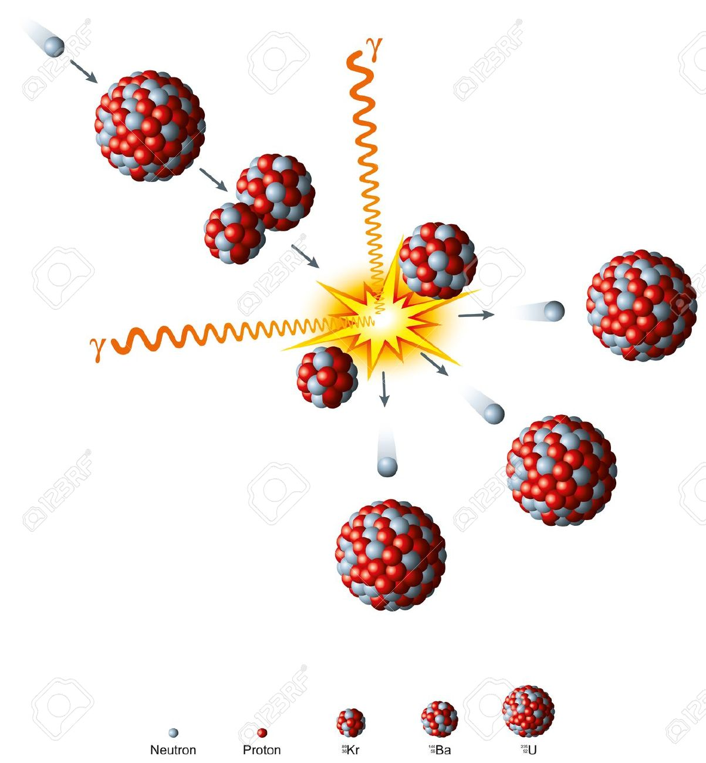
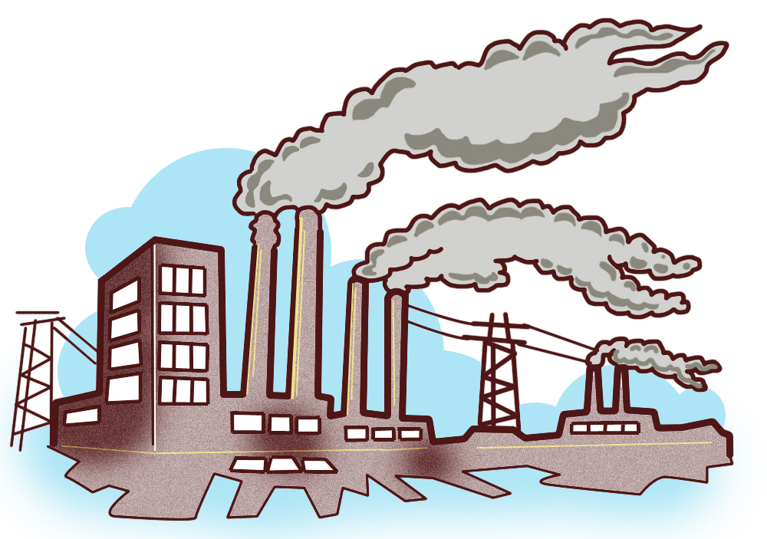

Structure of the Sun

The energy produced in the core of the sun radiates outwards through thousands of kilometres of very dense gases. This process takes a very long period of time, perhaps a million years for the radiation to get to the surface.

9. What does radiate mean? _____________________________________________________________________________

10. What does dense mean? ______________________________________________________________________________

The photosphere is the visible part of the sun, the bright disk we actually see. It is the coolest part of the sun, with a temperature of about 6000ºC. Over half the radiation released by the photosphere is visible light, with the remainder being infrared, ultraviolet, radio and X-rays.

The lower atmosphere of the sun is called the chromosphere. Bursts of glowing gases shoot up from the surface.
The upper part of the sun’s atmosphere is called the corona. Although the corona is outside the chromosphere and photosphere it is about 1 000 000ºC hotter than them.

The core is where the fusion of hydrogen occurs, releasing the energy.

The radiation zone is the area around the core where heat is radiated outwards.

The convection zone is the area under the photosphere, where the hot gases transfer energy to the sun’s surface by convection.

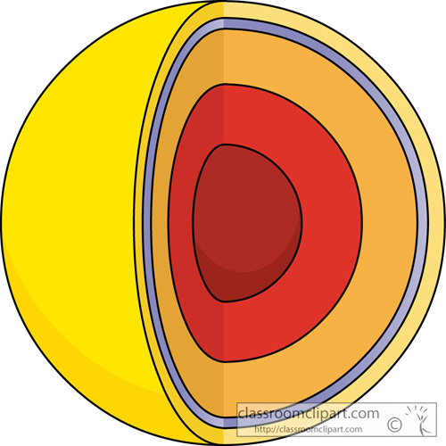
11. Use the information above to label the different layers of the sun below.

12. If you drew a scale diagram of the Earth next to this diagram of our sun could you see it? _______

